What is Relationship in DBMS?

A database is a structured data set that is usually electronically written in a computer system and stored as data. With their primary purpose being to maintain, keep, and extract data correctly, databases are important. In many practical situations, data is never an isolated file, and its correlations may be hidden. The occurrence of patterns in data is important to identify for effective data management. Here enters the word of data relationships in databases.

What is a Relationship in Database?
A relationship in a DBMS exists when the variable has a connection with the properties stored in different tables. Such relationships help the organization of entities intertwined with each other, ultimately enabling efficient data processing. They're exhibited usually via keys in a table, which is either columns or fields that specify a distinctive arrangement for each record.
As another example, one can think of the university database. Students, courses, and instructors, variably, might become tables. The relationship between the two tables is that courses indicate which courses the student can enroll in. Database management facilitates the reliable data apostrophe and performance of complex operations due to the fact that it guarantees the quality and identity of the data.

Why are Relationships Important in a Database?
Relationships are crucial in a database for several reasons:
- Data Integrity: The relationships make the necessary links between data sets and ensure that information kept and joined together is accurate. In this way, the consistency and correctness of the data are maintained.
- Efficient Data Retrieval: The relationship permits the complete search of data among multiple tables, storing fewer inputs and executing the query quickly, respectively.
- Normalization: Relations remain priorities that ensure the sync of data and achieving a level of relevance.
- Complex Data Analysis: Relationships empower users for state-of-the-art querying, aggregation, and analysis; thereby, users would be deriving meaningful insights from their data.
- Scalability: It has turned out that well-defined relationships, in their turn, are the key issue that helps the database to be scalable, thus having a structure that is easy to manage and could be further adapted to possible expanding business needs.

Types Of Relationships In Database

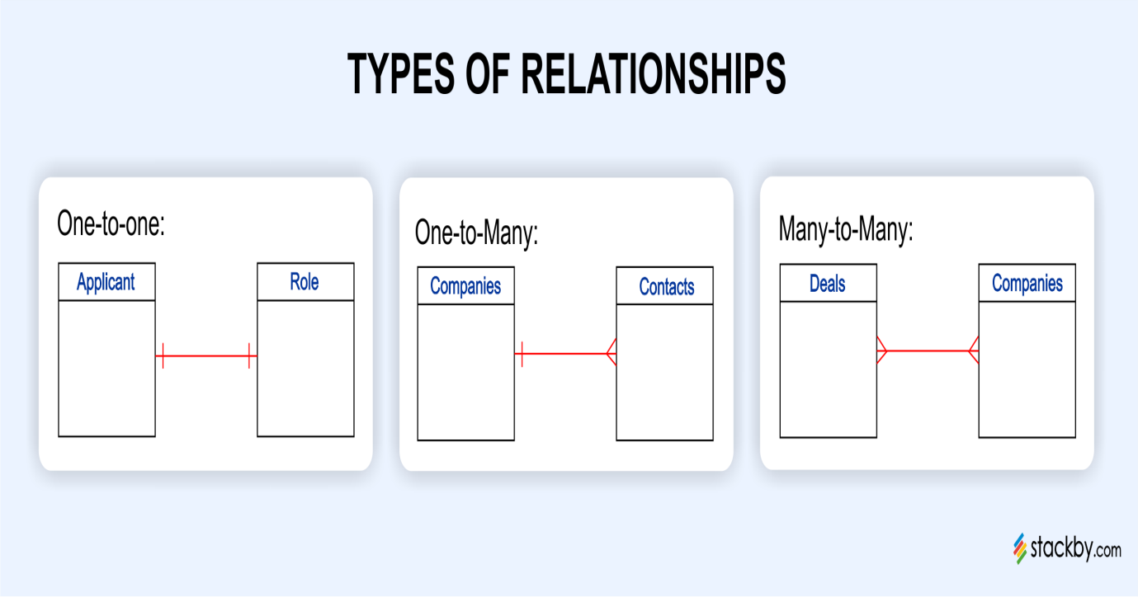

1. One-to-One (1:1) Relationship
In one to one relationships, a record is present in one table along with its corresponding existing relation, and the vacant relation among the records is present in another table. The type of relationship we are talking about is not as usual, and it is normally used when two entities that belong to a specific set need to be stored independently for normalization or security purposes. In another case, a person's employees' data consists of a record in the "personal details" table in a human resources database.

2. One-to-Many (1:N) Relationship
A relationship where the items from one table can be linked to only one or many items from another table is called a one-to-many relationship; in some cases, one item from the first table correlates with only one item from the second table. This connection becomes very strong in that it is particularly used to describe situations where one object can be linked to many similar or identical objects. For example, in an online store backend database, every customer may place multiple orders, yet the master customer record stays the same. If a record has more than one order, these are obtained from the backend database.

3. Many-to-Many (N:M) Relationship
The duality of a many-to-many relationship is characterized by the presence of multiple records belonging to a table in association with multiple records from another table. The interconnection of these relationships follows a junction table format, which is the component that holds both tables together. In the many-to-many relationship model, a wide variety of complex relationships can be established where each entity has many related entities. Such a database for a music streaming service could have a table representing each track that belongs to multiple playlists, and each of them could contain multiple tracks.

Conclusion
Calling upon relationships as the primary weapon, a solid database architecture will triumph in success by providing an ideal way to organize, retrieve, and analyze data. Relational databases understand this relationship concept: one-to-one, one-to-many, and many-to-many. Using this, they can have strong connections with the scenarios that exist in the real world. For instance, these hierarchies help avoid data corruption, maximize query performance, and grant the ability to extract amazing insights from data. Along with the companies that move to data-driven approaches, learning properly about data relationships is still a critical part of the real management of data and data analysis.

Tuple in DBMS

A tuple in DBMS refers to a single row in a relational table. It holds data for one specific record, with each value corresponding to a column (attribute) in the table. Tuples are unique and identified using a primary key, which prevents duplicates. They can be linked to tuples in other tables using foreign keys, allowing relationships between data.
The concept of tuples comes from the Relational Model introduced by E.F. Codd, where data is organized in tables (relations) as collections of unique tuples (rows).
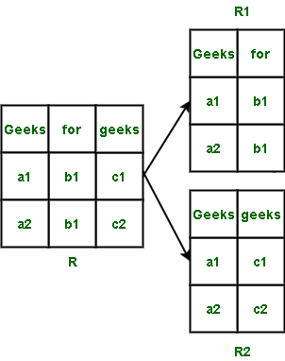
Tuples
The image represents the concept of tuples in a relational database and how they are organized across relations (tables).
Explanation:
- R is a relation (table) with 3 columns: Geeks, for, and geeks.
- Each row in the table R is a tuple. For example: Tuple 1: (a1, b1, c1),Tuple 2: (a2, b1, c2)
These rows represent individual records in the table.

Working with Tuple in DBMS
In a relational database, a relation is defined by a set of attributes and a set of tuples that have values for those attributes.
Example: A relation called "CUSTOMER" might have attributes such as "customer_id", "first_name", "last_name" and "email". Each tuple in the relationship would have a unique value for the "customer_id" attribute and corresponding values for the other attributes, such as "John" for "first_name" and "Smith" for "last_name".
CUSTOMER Table:

customer_id | first_name | last_name | email
1 | John | Smith | abc@gmail.com
2 | Abhishek | Bhosle | cde@gmail.com
3 | Natasha | Witch | fgh@gmail.com
Tuples are also used in the process of normalization in a relational database. Normalization is the process of organizing data in a database to minimize data redundancy and improve data integrity. In the process of normalization, a relation is broken down into multiple smaller relations, each with a specific purpose and containing a specific set of attributes and tuples.
Example: In an un-normalized relation, an "ORDER" relation may include attributes such as "order_id", "customer_id", "product_id" and "quantity". But, in the process of normalization, the relation may be broken down into two separate relations, one called "orders" containing attributes such as "order_id" and "customer_id" and another called "order_details" containing attributes such as "product_id" and "quantity".

ORDER Table:
order_id | customer_id | product_id | quantity
A | 1 | AAA1 | 5
B | 2 | BBB1 | 6
C | 3 | CCC1 | 7
D | 4 | BBB1 | 4
Tuples are also used in the process of querying a relational database. Queries are used to retrieve specific data from the database and the result of a query is a set of tuples that match the criteria specified in the query.
Example: A query to retrieve the first and last names of customers with a specific email address would return a set of tuples with those attributes for each customer that matches the criteria.

Types of Tuples
There are two types of tuples in a database management system:
- Physical Tuples
- Logical Tuples

1. Physical Tuple
A physical tuple refers to how a tuple is actually stored in memory or on disk in binary or encoded form.
Key Characteristics:
- Exists at the physical (storage) level of the database.
- Stored as a sequence of bytes or disk blocks.
- May include internal metadata like: Tuple ID (TID), Pointers to other tuples, Slot numbers and Null indicators
- Optimized for performance, indexing and retrieval.

2. Logical Tuple
A logical tuple is the abstract, user-level representation of a row in a relation (table). It is what users see, work with and query using SQL.
Key Characteristics:
- Exists at the logical (conceptual) level of the database.
- Represents data in terms of attributes and values.
- Independent of how data is stored on disk.
- Seen in queries, forms, reports, etc.
Note: Both physical and logical tuples have the same attributes, but their representation and usage can differ based on the context of the operation.

Attributes in DBMS

An Attribute is a property or characteristic that describes an entity in a database. It provides specific information used to identify, categorize, and manage entities effectively. Without attributes, entities have no meaningful data.
For example:
- Let's take the student as an entity. Students will have multiple attributes such as roll number, name, and class.
- These attributes are used to describe the student in more detail.
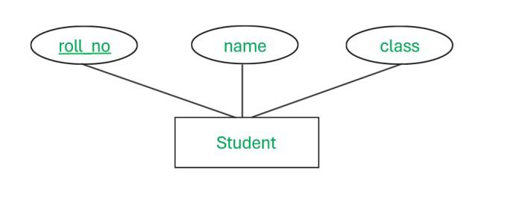
- As shown in the figure, roll_no, name, and class are the attributes of the entity Student.
- All three attributes give meaning to the entity. The information about the student entity lies in all 3 attributes.

Types Of Attribute
There are 8 types of Attributes in DBMS.

1. Simple Attribute
Simple Attributes are indivisible properties that hold basic information about an entity, such as name, roll number, or age. They cannot be broken down further and are often used to build other types of attributes.
Let's understand this with the help of example:
- Here in the below example, Student has roll_no, class, and name as attributes that cannot be divided into more sub-attributes.
- These types of attributes are called simple attributes.
- Simple attributes are mainly used to create all other types of attributes.
Simple Attribute

2. Composite Attribute
A composite attribute is formed by combining two or more simple attributes. It is used to represent complex data structures, like a full name made of first and last names.
Let's understand this with the help of example:
- Here if we look at the below example, address is the attribute derived from the 3 simple attributes i.e. City, State, and Street.
- To get the value of the address attribute, we have first to know those city, state, and street attributes.
- This type of attribute is known as a composite attribute.
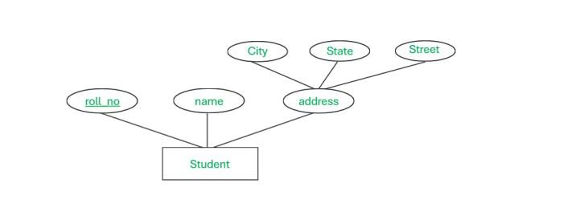Composite Attribute

3. Single Valued Attribute
A single-valued attribute contains only one value per entity instance. Mostly these attributes are used to provide the unique identity to the multiple instances of attributes.
Let's understand this with the help of Example:
- In the given example, we know that the DOB attribute will have only one value. So we can say that the DOB attribute is nothing but a single-valued attribute and it cannot have multiple attributes.
- Here roll_no and name will also have mostly one value only.
- We can say that all 3 attributes of the student are single-valued.
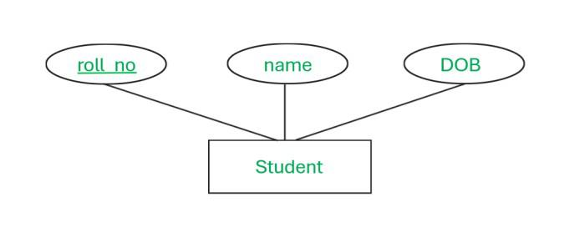Single valued attribute

4. Multivalued Attribute
A multivalued attribute can have multiple values for one entity instance. Unlike single-valued attributes, it stores several values linked to the entity.
Let's Understand this with the help of Example:
- In the given example, Student has an attribute named phone_no. One student can have multiple phone_no, so we can say that phone_no can have multiple values.
- These types of attributes are known as multi-valued attributes.
- Multi-valued attributes are used when more than 1 entries for one attribute need to be stored in the Database.
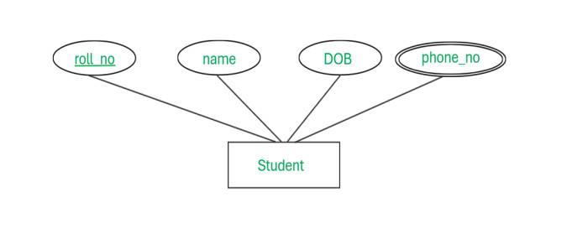Multi-valued attribute

5.Key Attribute
A key attribute has a unique value for every entity and is used to identify it. It plays an important role in ensuring data is distinct in a database.
Let's Understand this with the help of Example:
- For students, we can identify every student with roll_no because each student will have a unique roll_no.
- This indicates that roll_no will be a Key attribute for the Student entity.
- All operations on the database can be performed only using Key Attributes.
Key attribute

6. Derived Attribute
A derived attribute is an attribute calculated from other attributes in the database and is not physically stored. Its value is obtained using existing data within the same database.
Let's understand this with help of Example:
- Here the student has multiple attributes including DOB and age. It is observed that age can be calculated with the help of the DOB attribute.
- So age is a derived attribute that is derived from an attribute named DOB.
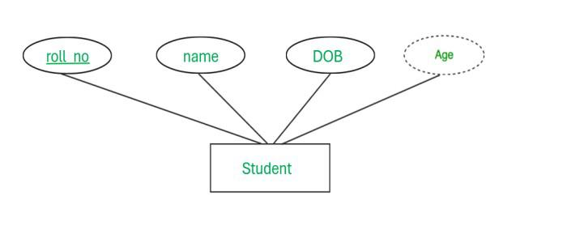Derived attribute

7. Stored Attribute
Stored attributes are physically stored in the database (unlike derived attributes). They can change (e.g., a student’s address), but they are stored directly, not calculated.. It stores permanent information that remains fixed throughout the entity’s lifetime.
Let's understand this with the help of example
- The student has 3 attributes as shown above. Her name and DOB will remain the same throughout his/her education. So the student has a fixed value attribute that will never change in the future.
- These attributes are known as stored attributes.
Stored attributes

8.Complex Attribute
A complex attribute is a combination of composite and multivalued attributes. It can contain multiple levels of sub-attributes. Complex attributes can have an unlimited number of sub-attributes.
Let's understand this with the help of Example:
- Here for the student, we created an attribute named contact_info which further decomposed into phone_no + Address.
- The address is a composite attribute which is further divided into simple attributes and phone_no is a multivalued attribute.
- This indicates that the contact_info attribute is made from the multi-valued and composite attribute.
- This type of attribute is known as the Complex Attribute.
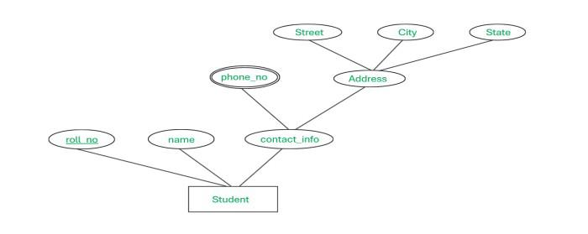Complex attributes

1. What is a Domain?
A Domain is the set of all possible valid values that an attribute can take.
In other words:
Domain = Allowed values for an attribute
Every Relational Database attribute must be associated with a domain.

Example
Relation: STUDENT
Roll_No | Name | Age | Department
101 | Ravi | 20 | CSE
Domains:
- Roll_No → positive integers
- Name → character strings
- Age → integers (17–30)
- Department → {CSE, ECE, MECH}

2. Formal Definition (Relational Theory)
Let a relation R(A1, A2, A3 … An)
Each attribute Ai has a domain Di
Domain(Ai) = Set of permitted values for attribute Ai
Example
STUDENT(Roll_No, Name, Age)
Domain(Roll_No) = integers
Domain(Name) = strings
Domain(Age) = integers between 17–30

3. Properties of a Domain (Important for GATE)

1. Atomic Values
Each value in a domain must be atomic (indivisible).
Example
Valid
Age = 20
Invalid
Age = (20,21)
This property supports the First Normal Form.

2. Same Domain Comparability
Attributes can be compared only if they belong to the same domain.
Example
Valid comparison
Student.Age > Employee.Age
Invalid comparison
Student.Name > Student.Age

3. Domain Independence
Domains are independent of relation size.
Adding or removing tuples does not change the domain.
Example
Age domain = 18–60
Even if table has only:
Age = 20
Age = 21
Domain still remains 18–60.

4. Types of Domains

1. Discrete Domain
A discrete domain contains countable values.

Example
Department = {CSE, ECE, MECH}
Grade = {A, B, C, D}
Characteristics
- Finite or countably infinite
- Distinct values
Example table
Student | Department
1 | CSE
2 | ECE
Domain = {CSE, ECE, MECH}

2. Continuous Domain
A continuous domain contains a range of values.

Example
Salary = 10000 – 100000
Temperature = -50 to 100
Weight = 0 – 200
Characteristics
- Infinite values in range
- Numeric measurements
Example
Employee | Salary
1 | 45000
2 | 62000
Domain
10000 ≤ Salary ≤ 100000

5. Domain vs Data Type
Many students confuse these.
Concept | Meaning
Data Type | Type of data stored
Domain | Allowed values
Example
Age INT
Data type = INT
But domain could be
Age = 18 – 60

6. Domain Constraints
A Domain Constraint restricts values of attributes.
Example
Age ≥ 18
Salary > 0
Department ∈ {CSE, ECE, MECH}
In SQL:
CREATE TABLE Student(
Age INT CHECK(Age >= 18)
);
Domain constraints are part of integrity constraints in DBMS.

7. Domain in SQL
Domains are implemented using:
- Data types
- CHECK constraints
- ENUM types
Example
CREATE TABLE Student(
Roll_No INT,
Name VARCHAR(30),
Age INT CHECK (Age BETWEEN 18 AND 30),
Department VARCHAR(10)
);
Here
Domain(Age) = 18–30

8. Domain Compatibility
Two attributes are domain compatible if:
- They have the same domain
- They have same data type
This is important for Relational Algebra operations like:
- UNION
- INTERSECTION
- DIFFERENCE
Example
Valid
Student(Age INT)
Employee(Age INT)
Invalid
Student(Name VARCHAR)
Employee(Age INT)

9. Domain in Relational Algebra
Operations such as:
- Union
- Intersection
- Set difference
require domain compatibility.
Example
R(A,B)
S(A,B)
Both must have
Domain(R.A) = Domain(S.A)
Domain(R.B) = Domain(S.B)

10. Domain vs Attribute vs Relation
Concept | Meaning
Domain | Set of allowed values
Attribute | Column
Tuple | Row
Relation | Table
Example
Roll_No | Name | Age
101 | Ravi | 20
Roll_No → Attribute
101 → Value
{positive integers} → Domain

11. Examples for GATE
Relation
EMPLOYEE(Eid, Name, Salary, Dept)
Domains
Domain(Eid) = positive integers
Domain(Name) = strings
Domain(Salary) = 10000–200000
Domain(Dept) = {HR, IT, SALES}

12. Common GATE Traps

Trap 1
Domain ≠ attribute values present in table.
Example
Table
Age = {20, 21}
Domain might be
18–60

Trap 2
Domain ≠ data type.
INT = data type
18–60 = domain

Trap 3
Domain is defined independent of relation size.

13. Very Short Revision (Exam Ready)
Domain = set of valid values for an attribute
Types
- Discrete Domain
  - Finite / countable values
  - Example → {CSE, ECE, MECH}
- Continuous Domain
  - Range of values
  - Example → Salary 10000–100000
Properties
- Atomic values
- Domain compatibility required
- Independent of relation size

